




Digital Design Verification
Lab Manual # 39 – Generating UVM Sequences & Connection to the DUT

Release: 1.0 Date: 11-Aug-
2024
NUST Chip Design Centre (NCDC), Islamabad, Pakistan

Copyrights ©, NUST Chip Design Centre (NCDC). All Rights Reserved. This document is prepared by NCDC and is for intended recipients only. It is not allowed to copy, modify, distribute or share, in part or full, without the consent of NCDC officials.

Revision History

Revision Number | Revision Date | Revision By | Nature of Revision | Approved By
1.0 | 11/08/2024 | Amber Khan | Complete Manual | -

Contents
Contents 2
Objective 3
Tools 3
Instructions for Lab Tasks 3
Task 1: Creating a Simple UVC 4
Task 2: Connecting to the DUT using Virtual Interfaces 9

Objective
The objectives of this lab are
- To use the uvm_sequence mechanism to define a sequence library and to control execution of sequences.
- To connect the YAPP UVC to the input ports of the DUT.

Tools
- SystemVerilog
- Cadence Xcelium Instructions for Lab Tasks
The submission must follow the hierarchy below, with the folder named after the student (no spaces), and the file names exactly as listed below.
./student_name_lab42/
├── task1_generating uvm sequences/
│  │ | ├── | tb/  ├──
│  │ |  | tb/  ├── | file.f
│  │  │  │  │  │  │  │  │  │  │  │ | ├── | ├──  ├──  ├──  sv/  ├──  ├──  ├──  ├──  ├──  ├──  ├──  ├── | top.sv router_tb.sv router_test_lib.sv  yapp_pkj.sv yapp_packet.sv yapp_tx_env.sv yapp_tx_agent.sv yapp_tx_driver.sv yapp_tx_monitor.sv yapp_tx_sequencer.sv yapp_tx_seqs.sv
├── | task2_DUT connection/
│ | ├── tb/
│ |  | ├── | file.f
│ |  | ├── | tb_top.sv
│ |  | ├── | router_tb.sv
│ |  | ├── router_test_lib.sv
│ |  | ├── clkgen
│  │ |  | ├── hw top dut  ├── hw top no dut
│ | ├── sv/
│  │ |  | ├──  ├── | yapp_if.sv yapp_pkg.sv
│ |  | ├── | yapp_packet.sv
│ |  | ├── | yapp_tx_env.sv
│ |  | ├── | yapp_tx_agent.sv
│ |  | ├── | yapp_tx_driver.sv
│ |  | ├── yapp_tx_monitor.sv
│ |  | ├── yapp_tx_sequencer.sv
│ |  | ├── | yapp_tx_seqs.sv

Task 1: Generating UVM Sequences
For this lab, you will explore sequence writing and the objection mechanism for coordinating simulation time.

Creating Sequences

- First – copy your YAPP files from lab04_factory/into lab05_seq/. Work in the lab05_seq directory.

- In the svdirectory, edit the sequences file, yapp_tx_seqs.sv, to add the sequences defined below in steps 3 to 9.

For every sequence:
  - Inherit the sequence from yapp_base_seqto use the objection mechanism.
  - At the start of every sequence body(), add an `uvm_infocall to print the sequence name. Use a verbosity of UVM_LOW.
  - Remember to add a data constructor and an object utilities macro.

- Create a single packet sequence with constraint:
yapp_1_seq– single packet to address 1 (addr==1)

- Create a multi-packet sequence with different constraints for each packet:
yapp_012_seq– three packets with incrementing addresses (addr ==0; addr==1; addr==2)

- Create a nested sequence.
yapp_111_seq– three packets to address 1 (do yapp_1_seqthree times)

- Create a repeating address sequence.
yapp_repeat_addr_seq– two packets to the same (random) address (addr==prev_addr: remember packet address cannot be 3)
Hint: Use a random sequence property with constraint

- Create a sequence to generate a single packet with incrementing payload data.
yapp_incr_payload_seq– Create a single packet to send.
Randomize the packet.
Set the payload values of the single packet to increment from 0 to (length -1). Update parity.
Send the packet.
Hint: Use `uvm_create and `uvm_send macros.

Running a Test Using a New Sequence

- Create a new test in the file router_test_lib.sv from the tbdirectory:
- Call the test incr_payload_testand extend from base_test.
- Add a uvm_config_wrapper::setto set the run_phasedefault sequence to yapp_incr_payload_seq.
- Add a set_type_override()method to use the short_yapp_packetdata type defined in Lab 4.
- Run the test and verify the results. Setting verbosity to UVM_FULLwill allow you to see which default sequence is executed in the run_phase().

Testing Your Sequences
You need to check that every one of your new sequences works correctly before we progress any further. There are several ways to do this, but the easiest is to create a single sequence which executes all the sequences you need to test.

- Edit the sequences file, sv/yapp_tx_seqs.sv, to add the following sequence:
yapp_exhaustive_seq– execute all sequences to test (Do all of your user-defined sequences).
Remember to extend from the base sequence and add a data utility macro and constructor. Using meaningful names for the sequence instances will help in debug.

- Create a new test in the file tb/router_test_lib.sv:
  - Call the test exhaustive_seq_testand extend from base_test.
  - Add a uvm_config_wrapper::setto set the run_phasedefault sequence to yapp_exhaustive_seq.
  - Add a set_type_override()method to use the short_yapp_packet data type
defined in Lab04.

Testing Your Sequences and Fixing Randomization Errors

- Run the test (+UVM_TESTNAME=exhaustive_seq_test) and check the results.
Note: You should get randomization failures for certain sequences due to constraint violations. Examine the simulation output carefully to see how the constraint violations are reported. Note that in batch mode, simulation is NOT stopped.

Randomization and Transaction Debug (SimVision)

- Run a SimVision GUI simulation by adding the following xrun command line options
-gui -access rwc

- The simulation will now stop on a constraint violation and the Constraints Manager window opened. This allows complex constraint violations to be easily debugged.
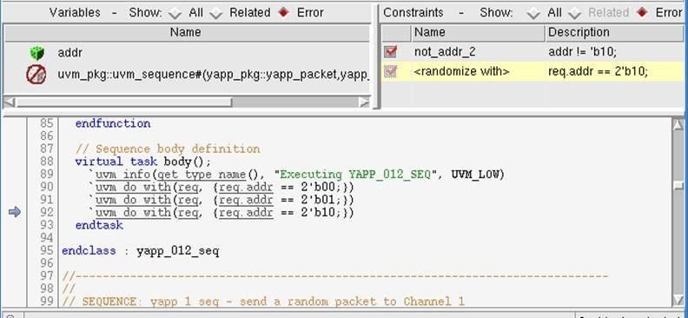

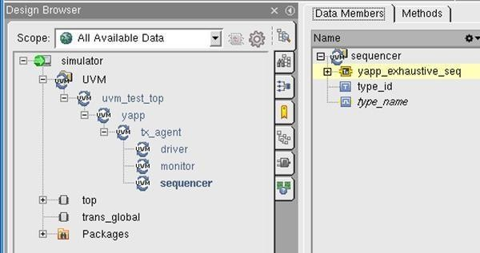
- In the Design Browser, navigate down the UVM hierarchy to your sequencer instance and find the sequence transaction (same name as your sequence). Add this to the waveform viewer.
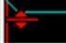
- Click ⊞ on the left of the transaction name to expand the sequence hierarchy
and pulldown the red-bar under the req transaction to see the packet data.
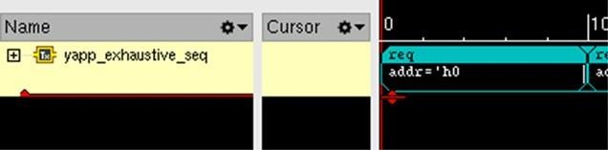

Randomization and Transaction Debug (Verisium Debug)
Verisium Debug is a separately licensed debug environment for Xcelium. Skip this section if you do not have access to this tool.

- Run Verisium Debug simulation by adding the following xrun command line option.
-debug_opts verisium_interactive

- Check the following tool settings:
  - In the left-hand toolbar, open settings , navigate to Randomization Debugger and make sure Enable Randomization Debug is selected.
  - Open Breakpoints from the bottom right
, select the Randomization tab, add a breakpoint for a Call status of Failure, and Apply. This will stop simulation on a randomization failure.

- Run simulation by selecting the play icon on the top toolbar. Simulation will stop at the randomization failure, show the failure message in the console pane and the failing `uvm_do_withmacro in the source pane.

Select Randomization Debugger from the left-hand tool bar 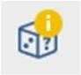 to debug the failure.
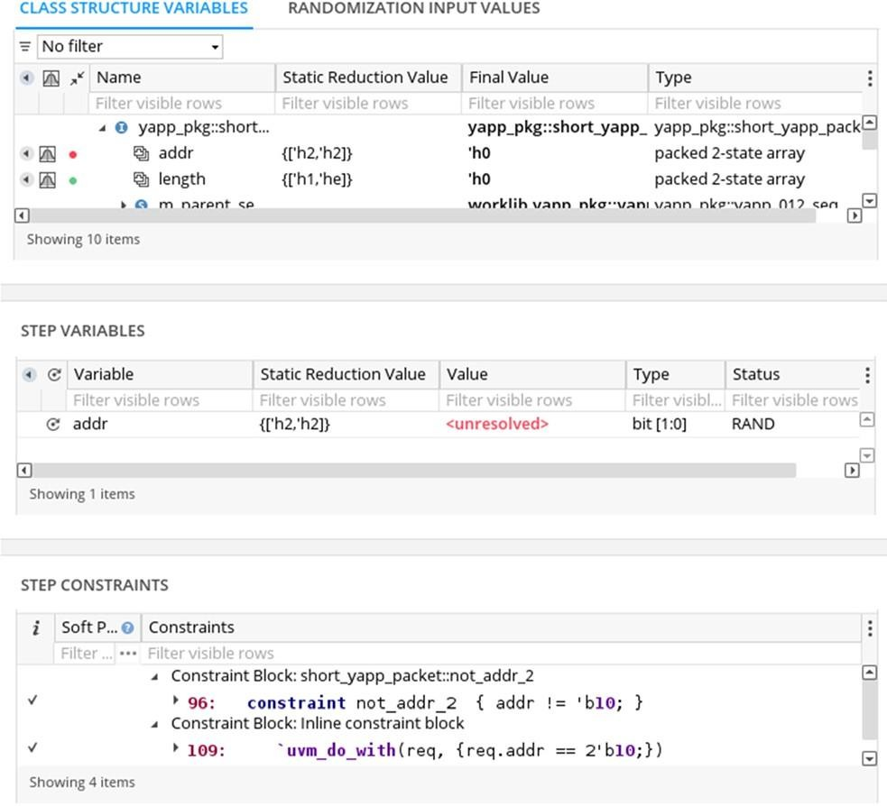
This shows the packet property values before randomization; the failing property (variable) addr and the conflicting constraints.

- Run simulation until the end. In the top left pane, select Hierarchy, then Test Bench to see the UVM hierarchy. Navigate to the YAPP sequencer instance, select the yapp_exhaustive_seqtransaction and right-click to Send to Wave.

- Use the two icons to the right of the transaction name
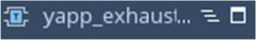 in the waveform viewer to expand the sequence hierarchy and show the transaction contents.

Understanding and Fixing the Randomization Failure

- Use the randomization and transaction debug features to answer the following questions:
Why do you get randomization violations?
Answer: What happens to the packet
when a constraint violation is found? Answer:
How could you fix these violations?
Answer:

- Fix your code to make the simulation run without constraint violations.
Hint: We will want to send short packets to every address.
It is important that you fix the randomization violations before moving on to the next lab.

- Create an additional sequence to generate a random number of packets.

yapp_rnd_seq–
Declare a randintproperty countin the sequence and generate a number of random packets according to the countvalue.
Set a constraint inside the sequence to limit countto the range 1 to 10. Include the value of countin the sequence `uvm_info message.

- Create a nested sequence with a constraint.
six_yapp_seq– do yapp_rnd_seqwith countconstrained to six.

- Add yapp_rnd_seqand six_yapp_seqto the
yapp_exhaustive_seqand verify their behavior in simulation.

Lab Task 2: Connecting to the DUT Using Virtual Interfaces
For this lab, you will connect your YAPP UVC to the RTL router Design Under Test (DUT) using interfaces and virtual interfaces.

Modifying the YAPP UVC

- First – copy your YAPP files from lab05_seq/into lab06_vif/. Work in the lab06_vifdirectory.

- Check the YAPP interface, yapp_if.svin the svdirectory. The interface has:
  - Two input ports (clock, reset)
  - Three DUT signals, in_data, in_data_vldand in_suspend.
  - Three methods, yapp_reset()and send_to_dut()for the driver, and collect_packets()for
the monitor

- Connecting the YAPP interface via the configuration database will be easier if you declare a typedeffor the uvm_config_dbwith a yapp_iftype parameter. This declaration has to be visible to your monitor, driver, and top-level module.
Add the following declaration to yapp_pkg.sv, before the include statements: typedef uvm_config_db#(virtual yapp_if) yapp_vif_config;

- Update your Monitor, yapp_tx_monitor.sv.
- Add a declaration for the virtual interface: virtual interface yapp_if vif;
- The monitor must call the collect_packets()interface method (using the virtual interface) to capture the packet data.
The method call and some of the declarations for the monitor are provided in the file
monitor_example.sv. Check you understand the code. Copy the code from the example into your monitor.
- Add a connect_phase()method containing a yapp_vif_config::getcall to assign viffrom the configuration database.
Remember getreturns bit 1 if it was successful. Test this return value in an if statement to help debug the virtual interface connection. For example:
if (!yapp_vif_config::get(this,"","vif", vif))
`uvm_error("NOVIF","vif not set")

- Update your Driver protocol, yapp_tx_driver.sv.
- Add a declaration for the virtual interface : virtual interface yapp_if vif;
- You need to call the send_to_dut()interface method to transmit packet data. You will also need to reset the input DUT signals when
the reset is active using a
reset_signals()method, and call this in the driver run_phase().
These methods and some of the declarations for the driver are provided in the file
driver_example.sv. Check you understand the code. Use the supplied code to update your driver.
- Add a connect_phase()method containing a yapp_vif_config::getcall to
assign viffrom the configuration database, as for the monitor.

Testing the DUT

- Add a new test by editing router_test_lib.sv:
- Create a new test which sets the default sequence of the YAPP UVC to yapp_012_seq. Sending packets to all three output Channels will make the DUT connection test much easier.
- Add a run_phase()method to base_testwhich sets a drain time for the objection mechanism as follows:
uvm_objection obj = phase.get_objection(); obj.set_drain_time(this, 200ns);
The drain time allows packets to pass through the router before simulation ends.

Initial Simulation Without the DUT

- A top-level module, hw_top.sv, is provided for you in the tbdirectory. The module supplies the following functionality:
- Instantiates the clkgenmodule to create the clocksignal.
- Declares the resetsignal and generates the waveform required.
- Instantiates the yapp_ifinterface:
- yapp_if in0 (clock, reset);
- Drives the in_suspend signal of the interface instance.
Check you understand the code in the module. No changes are required for this module at the moment.

In the tb directory, rename your UVM top level module top.sv to
tb_top.sv and modify the file as follows:

Change the module name to tb_top.
- Use a configuration set to write the YAPP interface instance into the config database as follows:
  - Use your yapp_vif_config typedef from step 3.
  - For a top module set, the context is null.
  - Use pathname wildcards to affect both monitor and driver with a single statement.
  - Use an absolute hierarchical pathname for the value to select the YAPP interface instance from the hw_top module.
- Update your run.f file:
- Add the YAPP interface file from the svdirectory to the list of files to be compiled. Remember interface files must be compiled, they cannot be included.
- Add clkgen.svand hw_top.svto the list of compilation files and change
top.svto tb_top.sv.
- You may need the following default timescale option in your run.f file to avoid timescale errors:
-timescale 1ns/1ns

- Run a simulation using yapp_012_testto verify your updates are working correctly.
- Examine the simulation output carefully to check that the YAPP monitor is capturing correct packets according to the sequence being used.
- Run the simulation in GUI mode and use the waveform viewer to check your interface signals are correctly driven.
Hint: Select the interface instance in the Design Browser window or Hierarchy tab and send to the waveform window to display all the interface signals.

Testing with the DUT
Now is the time to test your YAPP UVC with the actual router DUT, the model for which can be found in the router_rtldirectory (at the same level as your lab directories).
With a few lines of extra code, the router DUT will function without any connections to the HBUS interface signals or the channel outputs. This will allow you to test your YAPP UVC connection to the DUT without having to use the HBUS or Channel UVCs.

- Edit hw_top.svas follows:
- Copy the DUT instance and port list from the file yapp_router_instance.txt and use named mapping to connect clock, resetand the YAPP interface signals. Leave the other ports unconnected. For example:
.in_data(in0.in_data), //connect YAPP data
.data_0(), // leave Chan0 data unconnected
- In the initialblock, remove the following assignment to in_suspendas this will now be driven by the router DUT itself.
in0.in_suspend <= 0;
- Set the suspend_0, suspend_1and suspend_2router channel ports to 1’b0
in the DUT instance port mapping. This allows packets to pass through the DUT.
- Modify run.fto compile the yapp_router.svfile from the router_rtl directory.

- Run a simulation in GUI mode to make sure the router is correctly connected.
- Use the waveform viewer to check packet data comes out on the right output channels, by adding the following signals from topto the waveform viewer:
  - in_datafrom the in0YAPP interface instance
  - data_0, data_1and data_2output ports from the dutmodule instance.
You should see packet data going into the router on in_dataand coming out on the correct channel data output port.
- You can also view the YAPP monitor and driver transactions. Navigate down the UVM hierarchy from uvm_test_topto your monitor and driver instances. Add the following named transactions to the waveform viewer:
  - Monitor_YAPP_Packet
  - Driver_YAPP_Packet
These names are defined in the driver and monitor transaction method calls, e.g. in the driver get_and_drive()task
begin_tr(req, "Driver_YAPP_Packet");

